By:

Sudhanshu Rai

DATA QUALITY REPORT

**Section 1 - High Level Description**

* The dataset contains information about New York properties.
* There are 1070994 rows in the dataset.
* It contains 32 fields.
* Source of data: <https://data.cityofnewyork.us/Housing-Development/Property-Valuation-and-Assessment-Data/rgy2-tti8>
* Most fields are 100% populated, but certain fields such as AVLAND2, AVTOT2 etc are less than 50% populated.

**Section 2 – Field Summary Tables**

The following section contains two tables, based on categorical and numerical values, providing some basic insights about different fields.

**2.1 Numerical Fields:**

|  |  |  |  |  |  |  |
| --- | --- | --- | --- | --- | --- | --- |
| **Field Name** | **% Populated** | **Min** | **Max** | **Mean** | **Standard deviation** | **% Zero** |
| **LTFRONT** | 100% | 0 | 9999 | 36.64 | 74.03 | 15.79% |
| **LTDEPTH** | 100% | 0 | 9999 | 88.86 | 76.39 | 15.88% |
| **STORIES** | 94.75% | 1 | 119 | 5.00 | 8.365 | 0% |
| **FULLVAL** | 100% | 0 | 6,150,000,000 | 874,264.50 | 11,582,430.99 | 1.21% |
| **AVLAND** | 100% | 0 | 2,668,500,000 | 85,067.91 | 4,057,260.05 | 1.21% |
| **AVTOT** | 100% | 0 | 4,668,308,947 | 227,238.16 | 6,877,529.30 | 1.21% |
| **EXLAND** | 100% | 0 | 2,668,500,000 | 36,423.89 | 3,981,575.79 | 45.91% |
| **EXTOT** | 100% | 0 | 4,668,308,947 | 91,186.98 | 6,508,402.81 | 40.39% |
| **BLDFRONT** | 100% | 0 | 7575 | 23.04 | 35.58 | 21.36% |
| **BLDDEPTH** | 100% | 0 | 9393 | 39.92 | 42.70 | 21.36% |
| **AVLAND2** | 26.39% | 3 | 2,371,005,000 | 246,235.71 | 6,178,962.56 | 0% |
| **AVTOT2** | 26.39% | 3 | 4,501,180,002 | 713,911.43 | 11,652,528.94 | 0% |
| **EXLAND2** | 8.16% | 1 | 2,371,005,000 | 351,235.68 | 10,802,212.67 | 0% |
| **EXTOT2** | 12.21% | 7 | 4,501,180,002 | 656,768.28 | 16,072,510.17 | 0% |

**2.2 Categorical Fields**

|  |  |  |  |
| --- | --- | --- | --- |
| **Field Name** | **% Populated** | **% Unique Values** | **Most Common Values** |
| **RECORD** | 100% | 100% | All with frequency 1 |
| **BBLE** | 100% | 100% | All with frequency 1 |
| **BORO** | 100% | 0.00046% | 4 |
| **BLOCK** | 100% | 1.31% | Block number: 3944 |
| **LOT** | 100% | 0.594% | Lot number: 1 |
| **EASEMENT** | 0.432% | 0.258% | Easement: E |
| **OWNER** | 97.03% | 80.61% | Parkchester Preservat |
| **BLDGCL** | 100% | 0.02% | R4 |
| **TAXCLASS** | 100% | 0.001% | 1 |
| **EXT** | 33.08% | 0.00084% | G |
| **EXCD1** | 59.61% | 0.02% | 1017 |
| **STADDR** | 99.93% | 78.41% | 501 SURF AVENUE |
| **ZIP** | 97.21% | 0.018% | 10314 |
| **EXMPTCL** | 1.45% | 0.096% | X1 |
| **EXCD2** | 8.67% | 0.0645% | 1017 |
| **PERIOD** | 100% | 0.00009% | FINAL |
| **YEAR** | 100% | 0.00009% | 2010/11 |
| **VALTYPE** | 100% | 0.00009% | AC-TR |

**Section 3 Graphs and Charts**

1. **RECORD:** This is index value of the table and contains incremental values.
2. **BBLE:** This is a unique field, which stands for Borough, Block and Lot numbers and helps uniquely identify the property in New York.
   1. The first place is the Borough number, which is between 1 to 5
   2. The next 5 places are Block number, which is again numeric
   3. The last 4 places are Lot number

**NOTE:** There are around 4636 BBLE values in table which ends with an extra alphabet ‘E’,’F’,’G’ and the lot number does not contain these extra alphabets. These can be possible noises or error in saving BBLE.

1. **BORO:** This field contains 5 values, 1,2,3,4,5 representing 5 Boroughs in New York.
   1. 1- The Bronx
   2. 2- Brooklyn
   3. 3- Manhattan
   4. 4- Queens
   5. 5- State Island

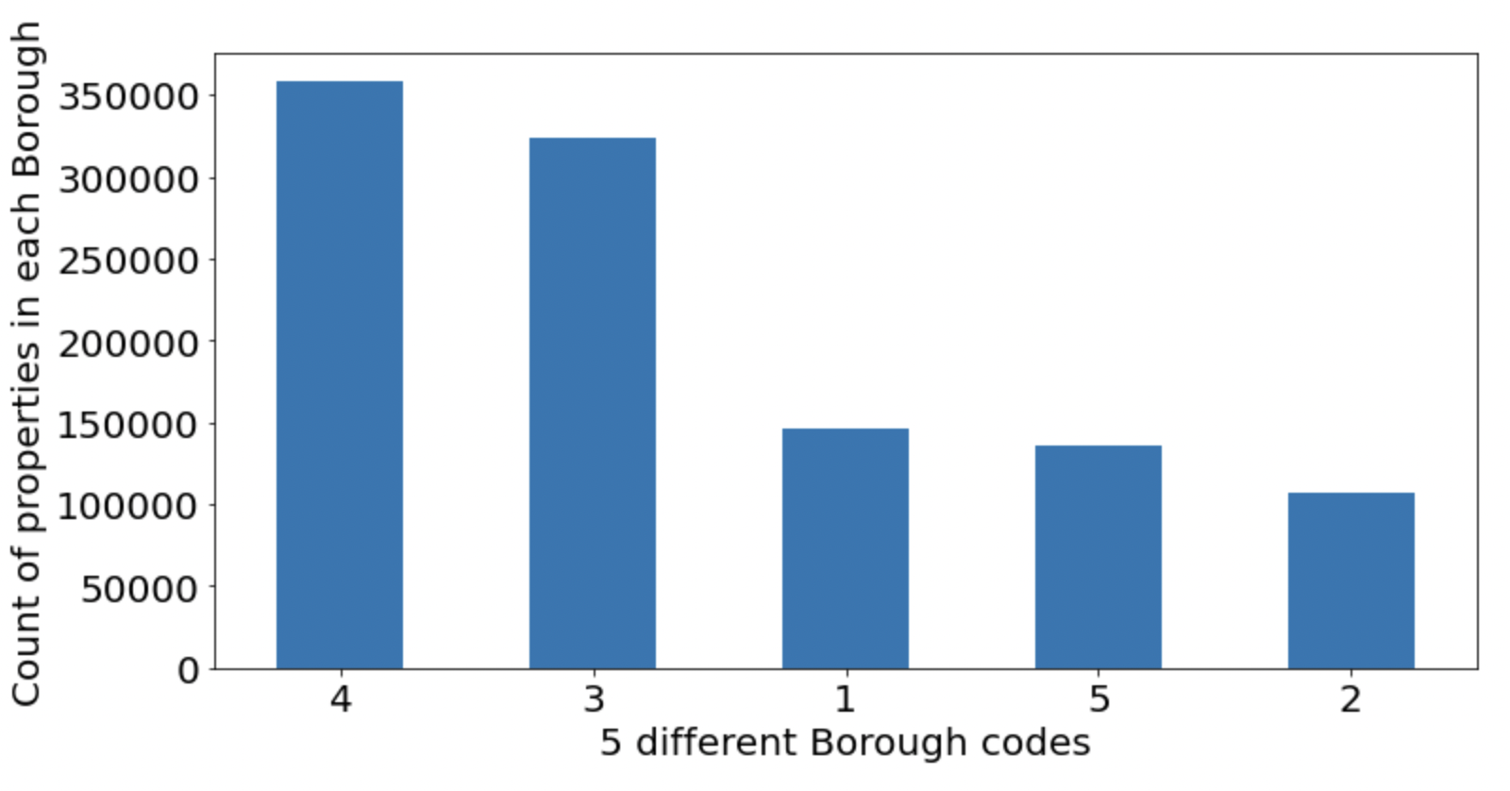

1. **BLOCK:** Categorical Field containing 13984 unique values, which represent the block number in any Borough. A particular block number is present in more than one borough.

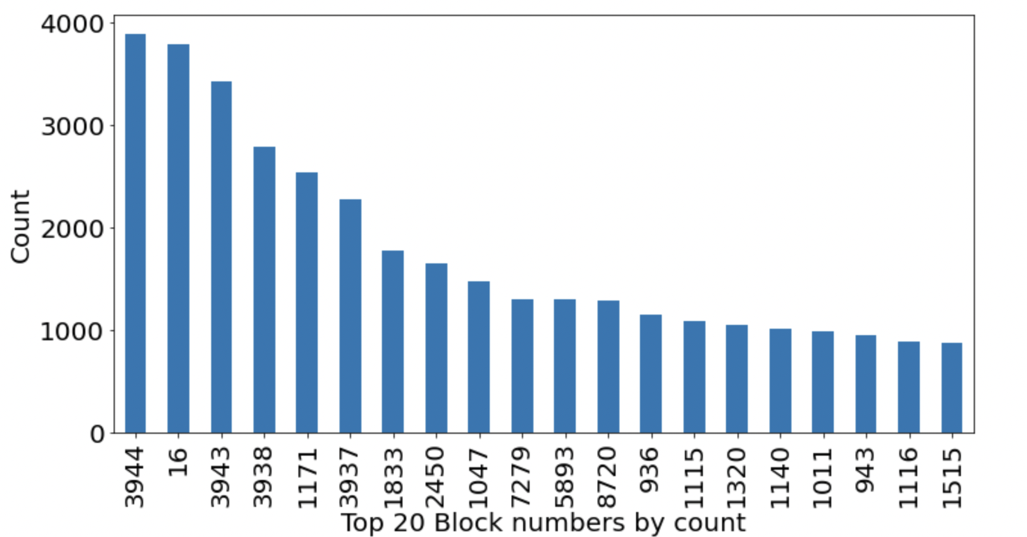

1. **LOT:** 6366 unique values are there in this field. This field is again a part of BBLE. Lot number 1 has the highest number of properties.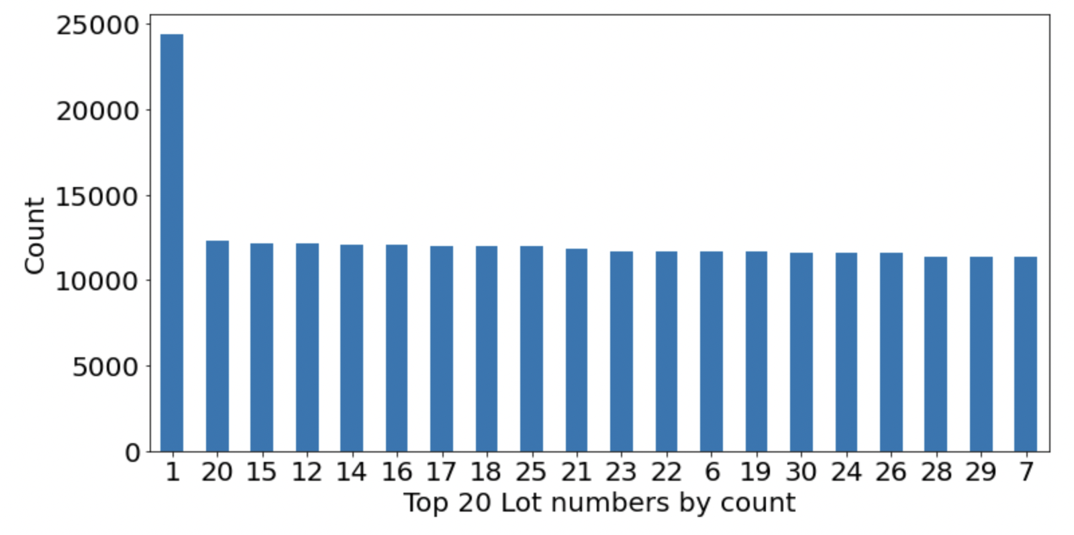
2. **EASEMENT:** The simplest easement definition is that an easement gives a person or entity the right to access real property that’s owned by someone else for a limited and specific purpose. Easements can affect property owners in a couple of different ways.
   1. Only 0.5% of values are populated and rest values are NA.
   2. Easement is a categorical variable which contains 12 unique values.

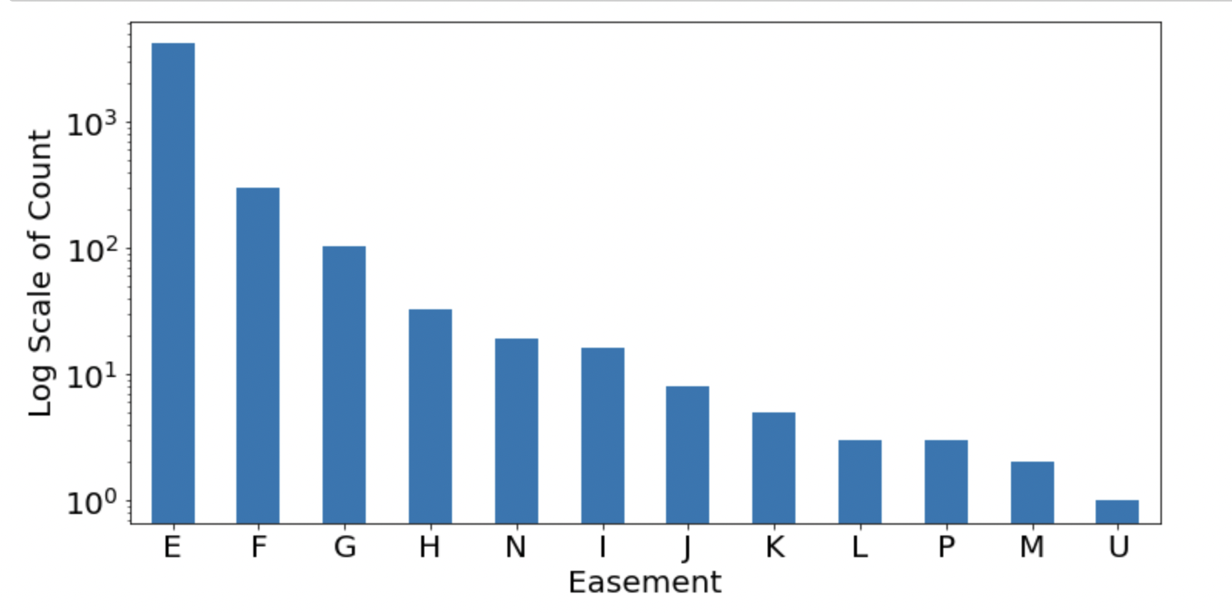

1. **OWNER:** Categorical variable containing text values, stating the owner of the property. It contains up to 80% of unique values and about 3% values are missing.

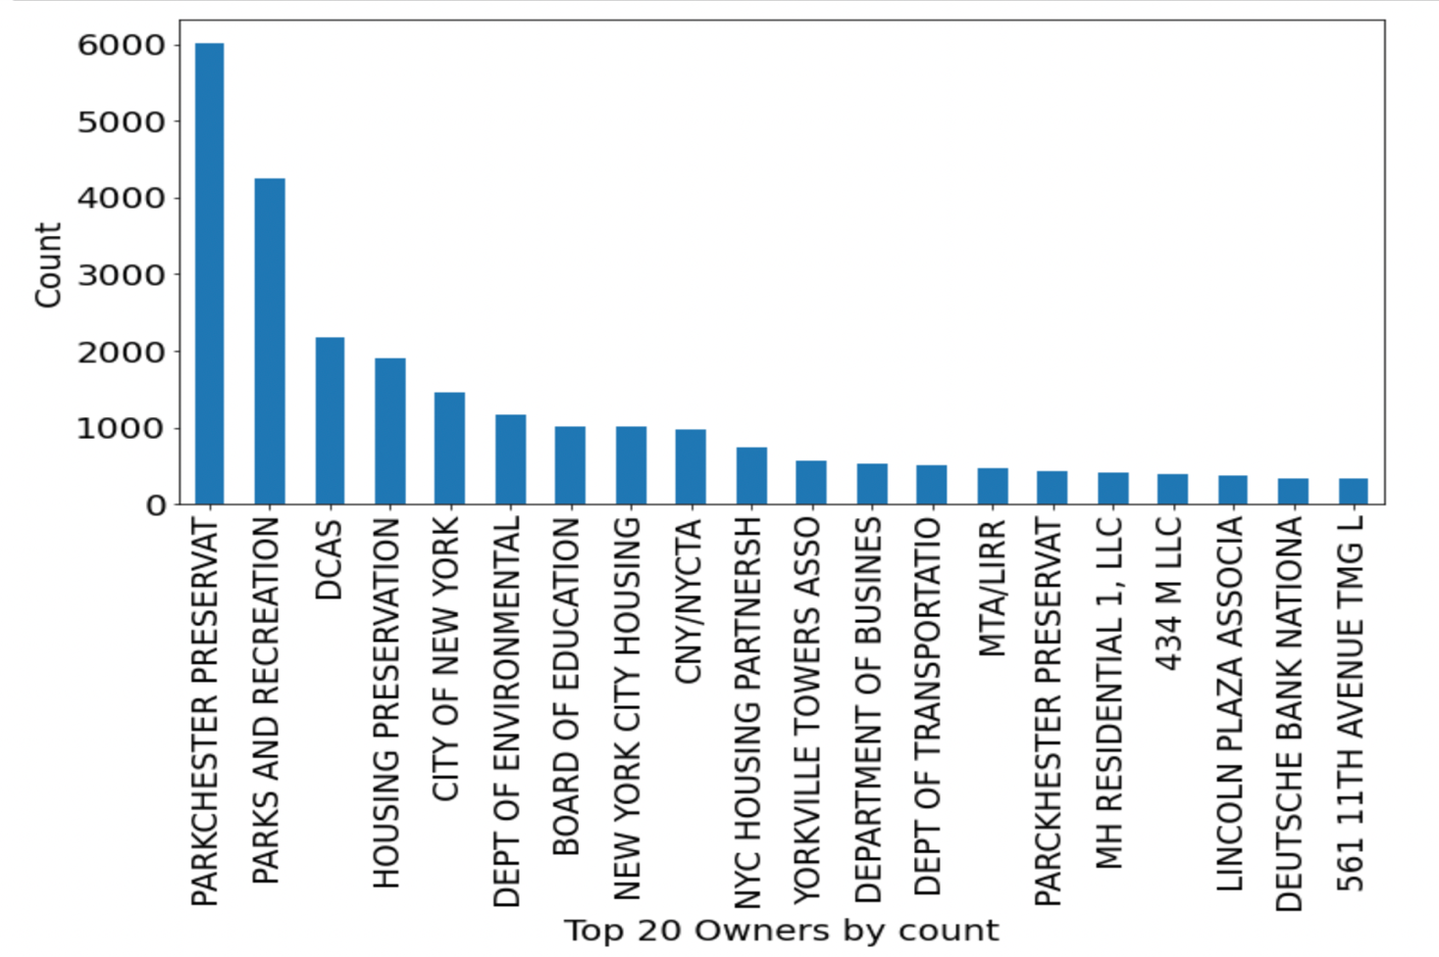

1. **BLDGCL:** Categorical Variable, containing Building classification, containing alpha numeric combination of an alphabet and a number, given the information about the type of building. For example, H1 is luxury hotel, N3 is orphanage, P7 is museum etc.

The most common property in this dataset is R4, Condo, residential unit in elevator building.

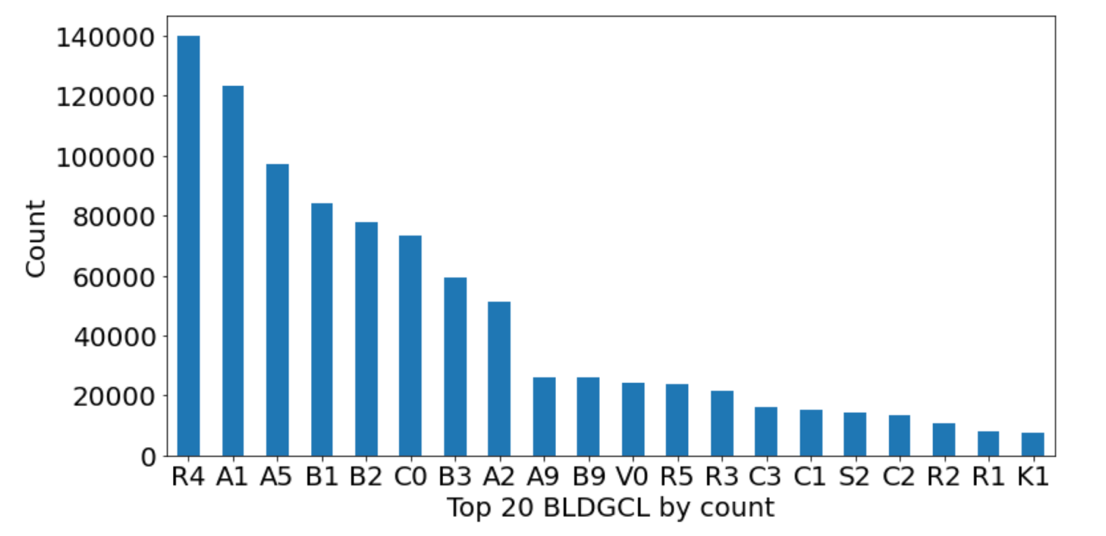

1. **TAXCLASS:** It is a categorical variable containing Class codes, depending on type of property. For example:

|  |  |
| --- | --- |
| Class 1 | Class 1 property means property owned or controlled by a state agency concerning which there are no encumbrances or deed restrictions that limit the exploration or drilling for oil or gas on the property. |
| Class 2 | Class 2 includes residential properties with more than three units, including cooperatives and condominiums. |
| Class 3 | Class 3 property means Assessed Property that is or is intended to be developed as multifamily rental units under common management (e.g., apartments), including any ancillary uses thereto. |
| Class 4 | class 4 property means property owned or controlled by a state agency concerning which there is a provision in the deed that limits the exploration or drilling for oil or gas on the property. |

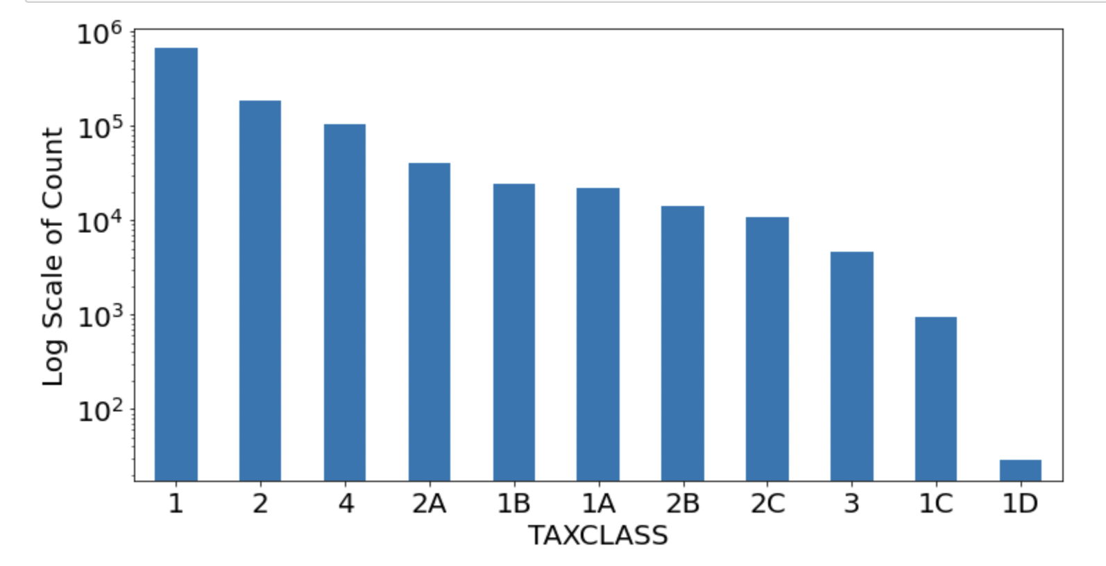

1. **LTFRONT:** Numerical value containing 15% of values as zero. And most values between 10 and 50.

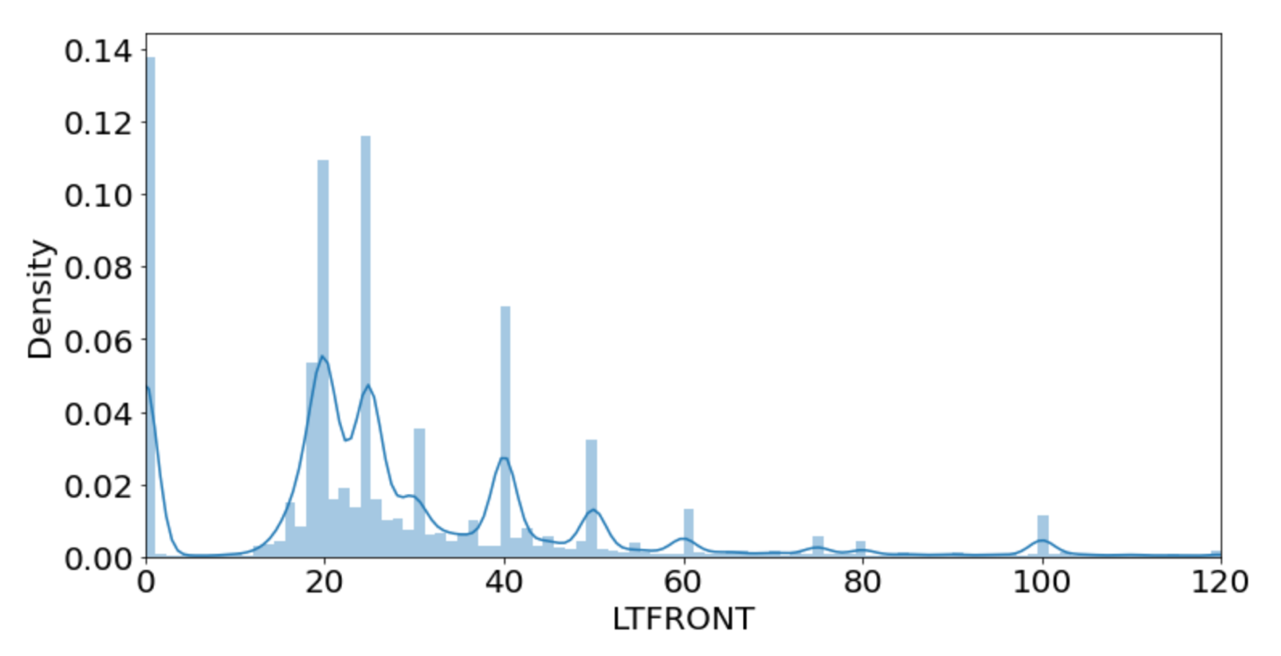

1. **LTDEPTH:** Numerical value containing about 15% of values as zero. And most values between 80 and 120. Assuming that the values which are zero, are either NA or not provided, we can analyze that most values lie around value 100.

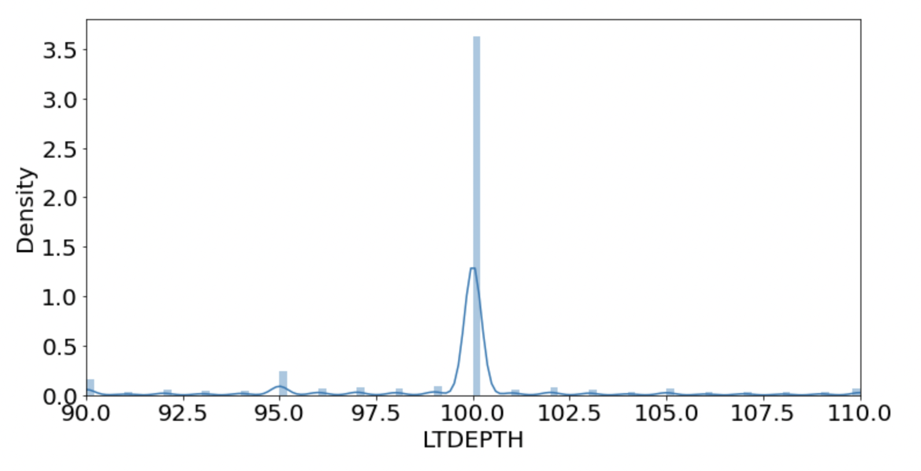

1. **EXT:** Categorical field containing 3 unique values, ‘E’, ‘G’ and ‘EG’. With ‘G’ as the most common value with over 250k entries. Also, only one third of the values are populated and rest are null.

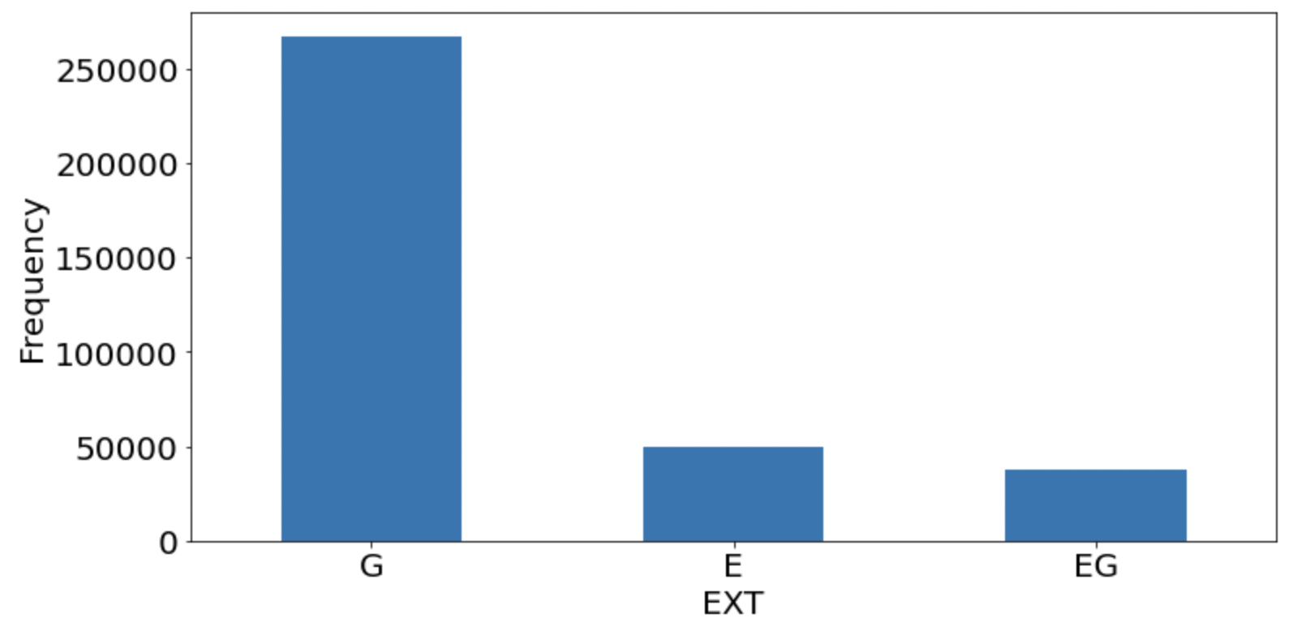

1. **STORIES:** Numerical value containing number of stories in building.

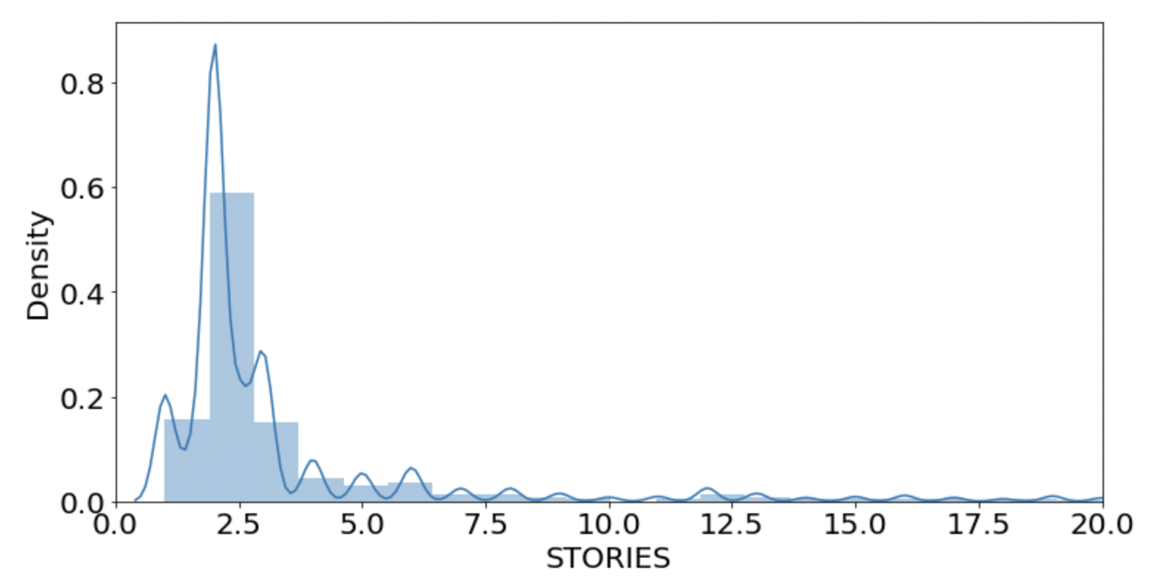

1. **FULLVAL:** Numerical variable containing values between 0 and as high as 6 million. With most values within 0 to 1.5 million.

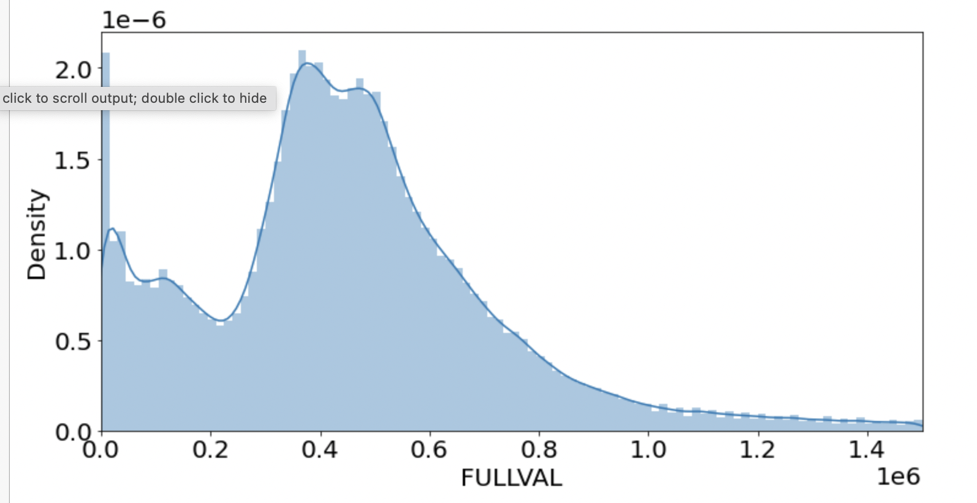

1. **AVLAND:** Numerical field containing all the rows as populated and values between 0 and 2.6 million.

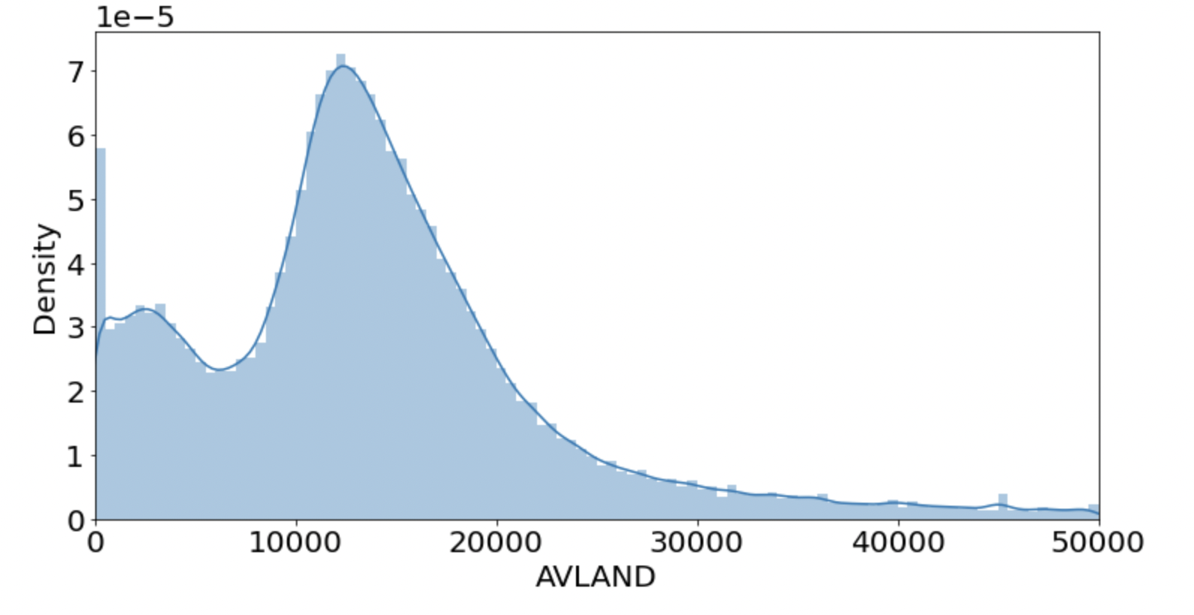

1. **AVTOT:** Another numerical value, containing values between 0 and 2.6 million. With most values between 0 and 100,000.

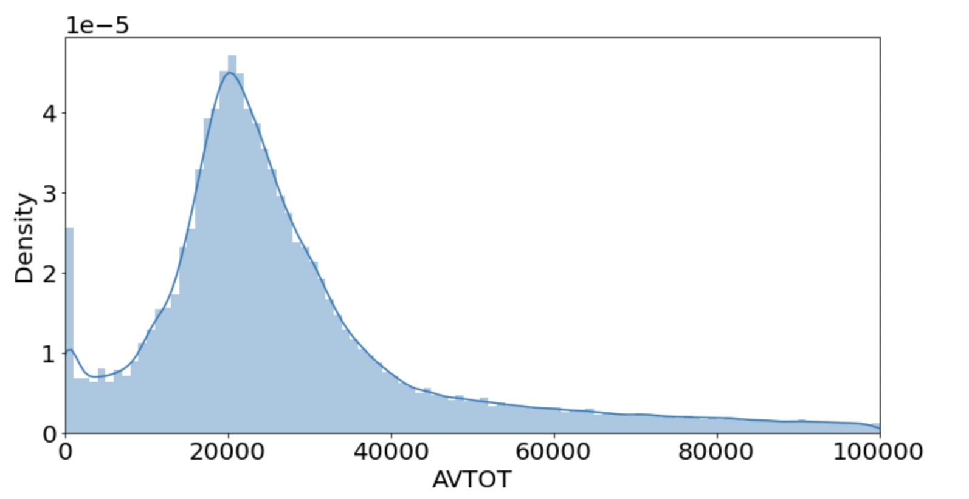

1. **EXLAND:** Numerical value containing values between 0 and 2.6 million. It contains 45% of values as zero.

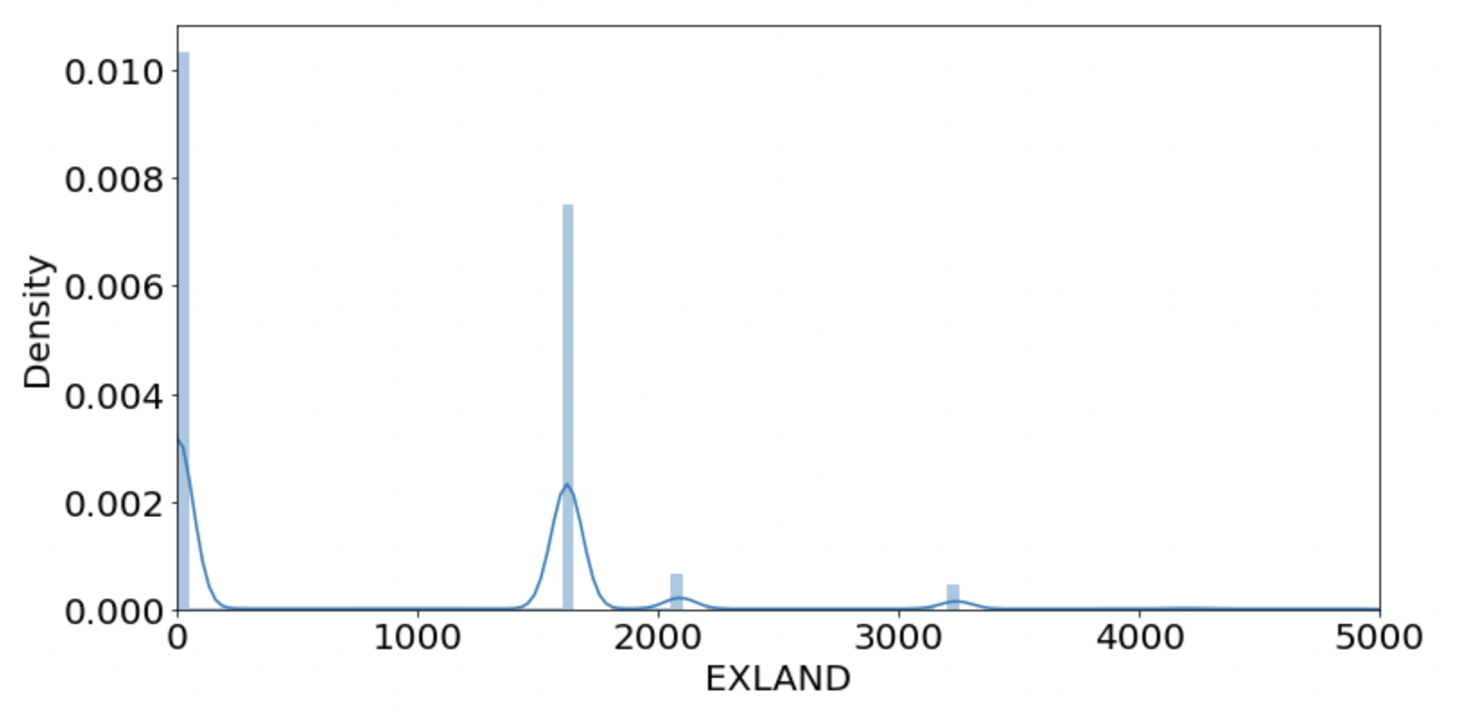

1. **EXTOT:** Numerical value containing values between 0 and 4.6 million. It contains about 40% of values as zero. If 0 values are null or not provided. Following graph gives us an insight into the distribution.

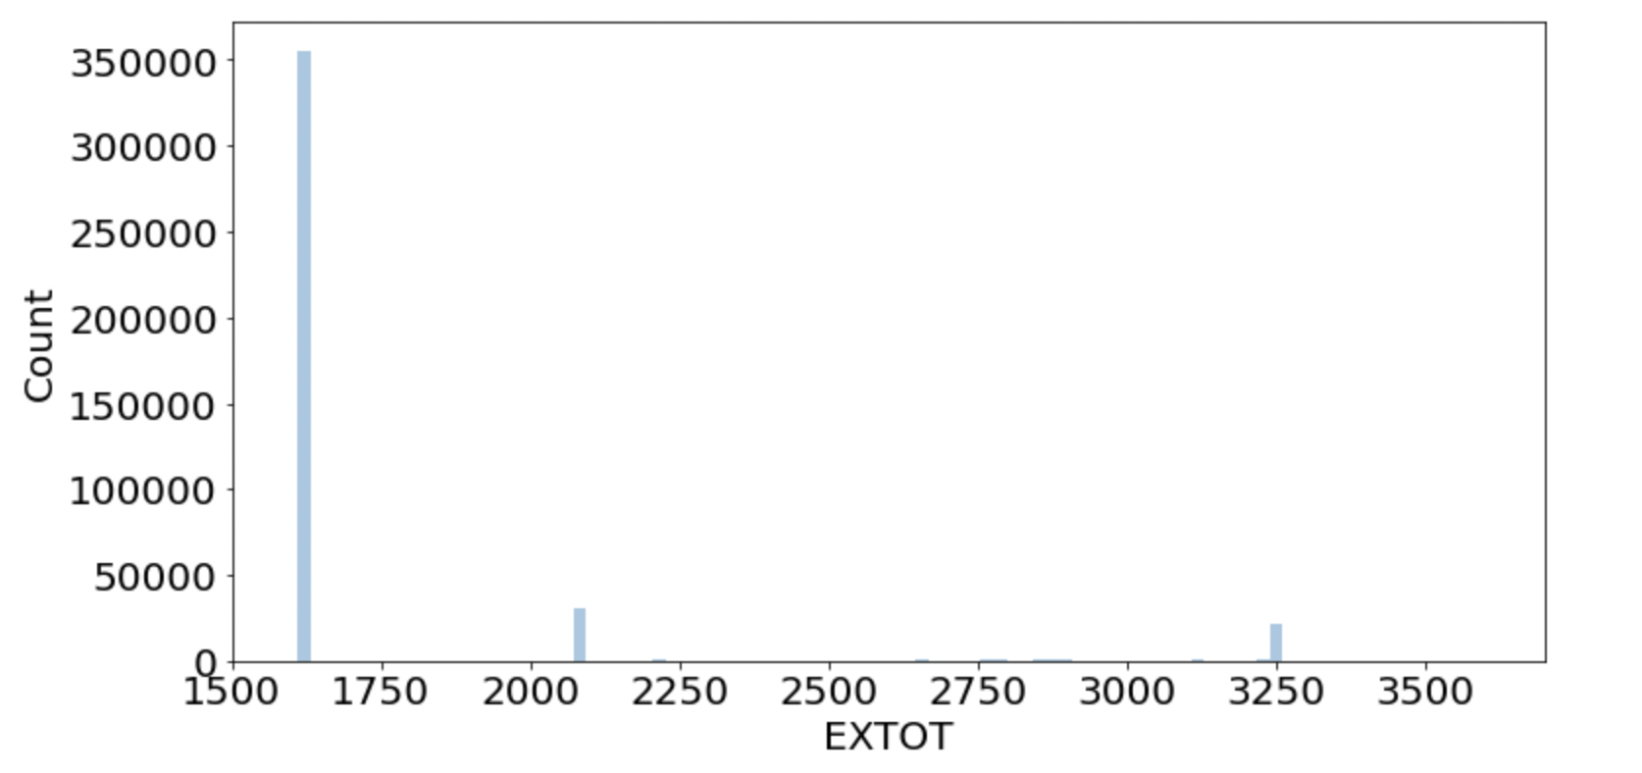

1. **EXCD1:** Categorical field containing 129 distinct values, but the greatest number of rows containing value 1017. And only 60% of values are populated while the rest are null.

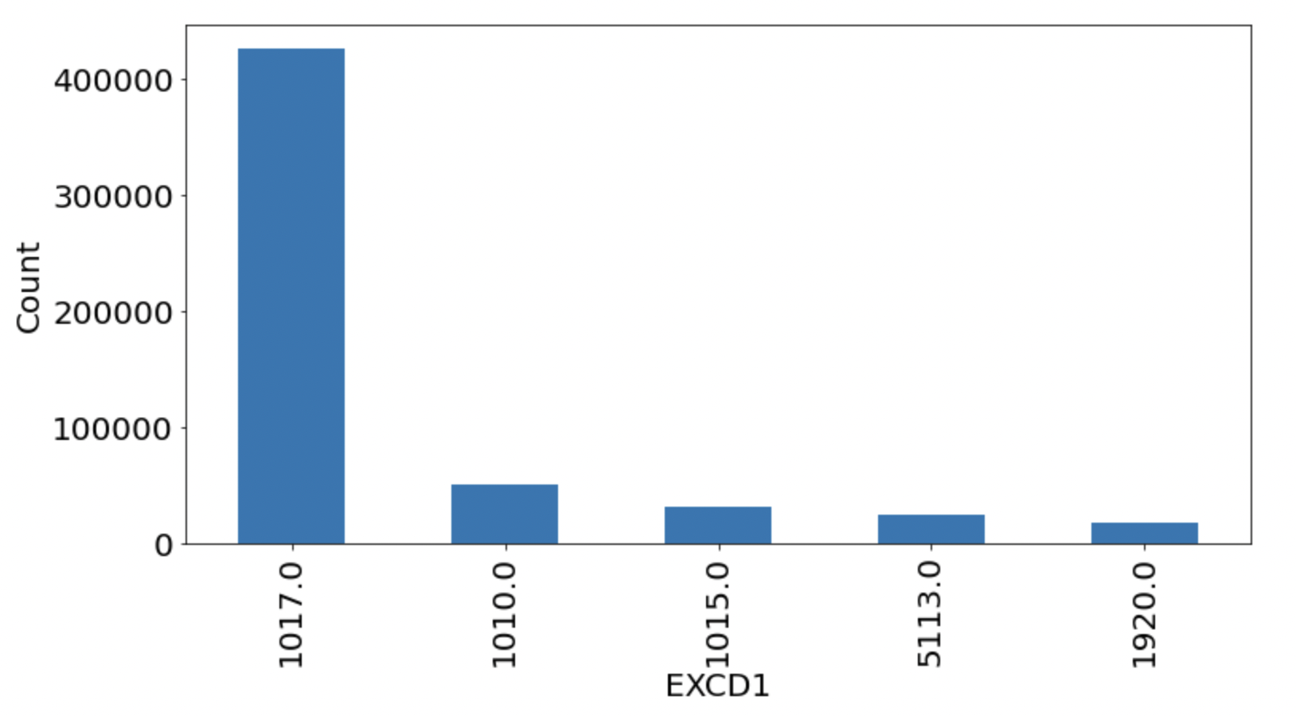

1. **STADDR:** Text field containing categorical values, having around 79% of unique values. Most common value being, 501 SURF AVENUE.

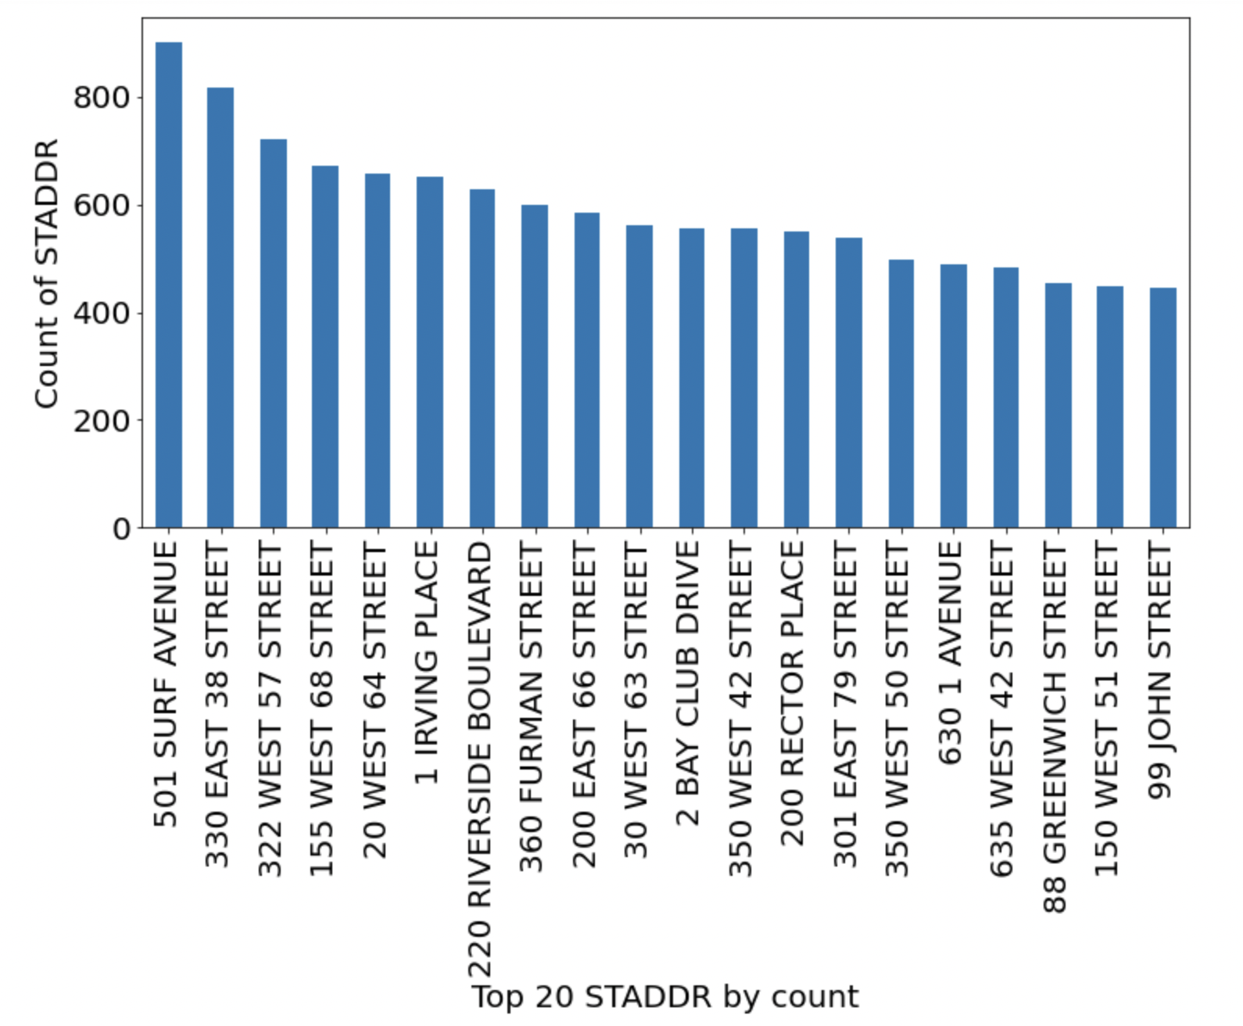

1. **ZIP:** Categorical field containing Zip codes of the properties, having 196 unique zip codes.

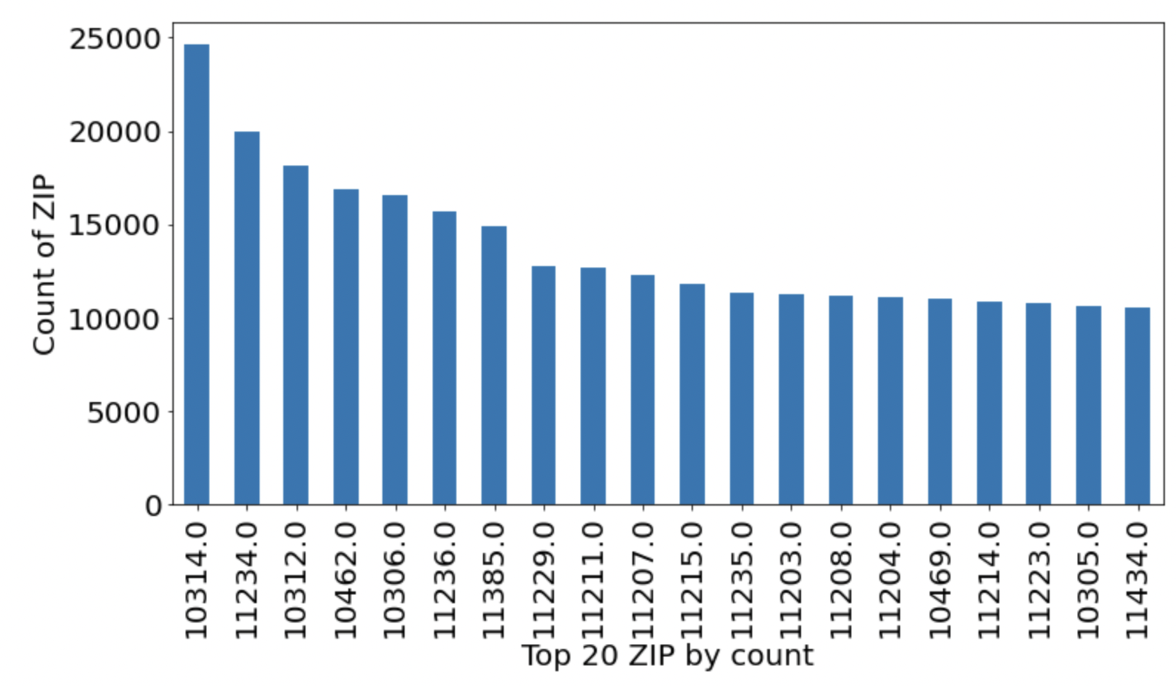

1. **EXMPTCL:** Categorical variable containing 14 unique values. Over 98% rows in this field are null.

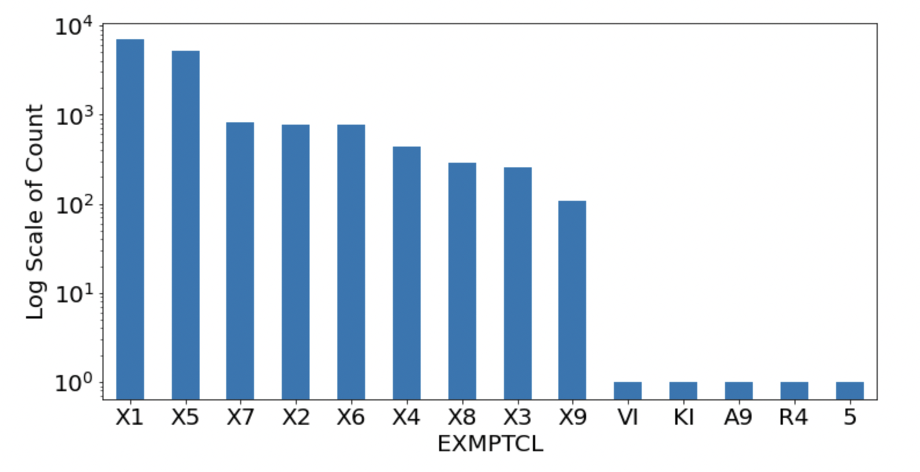

1. **BLDFRONT:** Numerical variable containing 22% values as 0. Graph removing values as 0 assuming that they are null or not provided.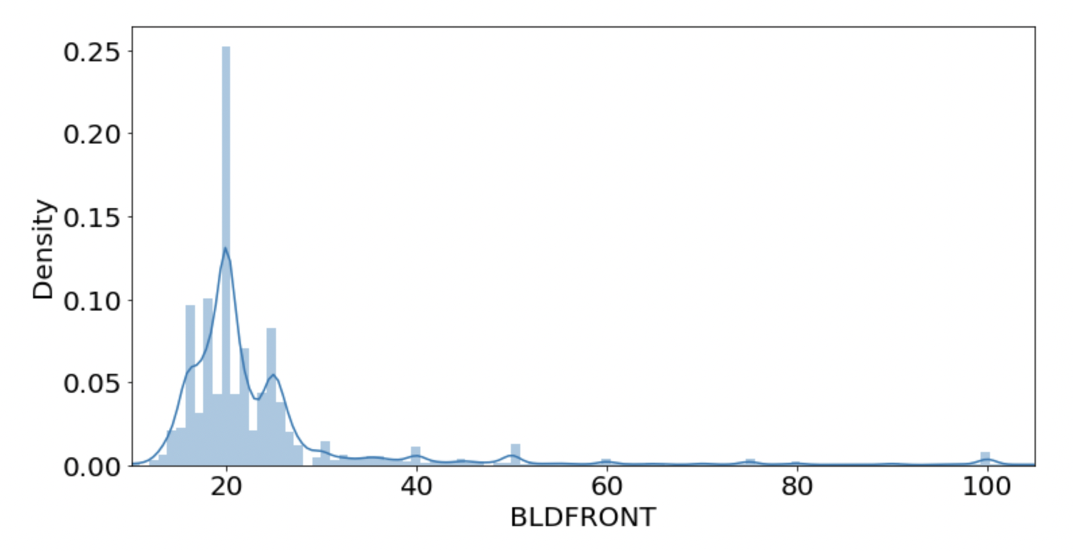
2. **BLDDEPTH:** Numerical variable containing about 22% of values as zero.

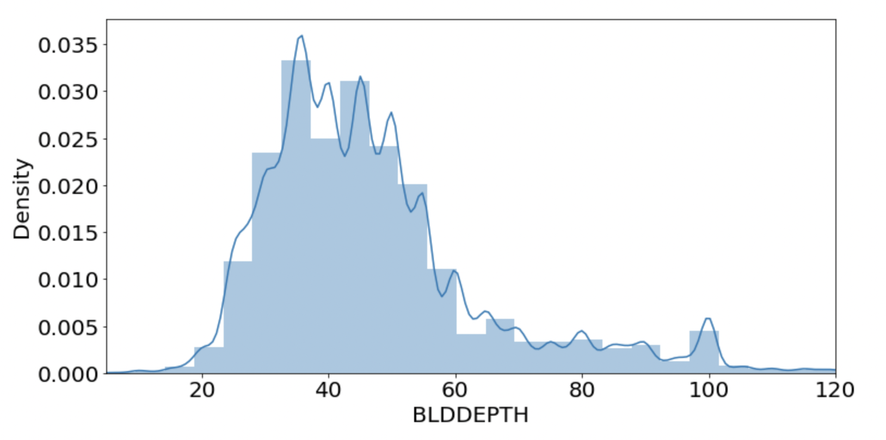

1. **AVLAND2:** Numerical value, containing only 26% populated values, containing 3 as minimum value and value as high as 2.3 million.

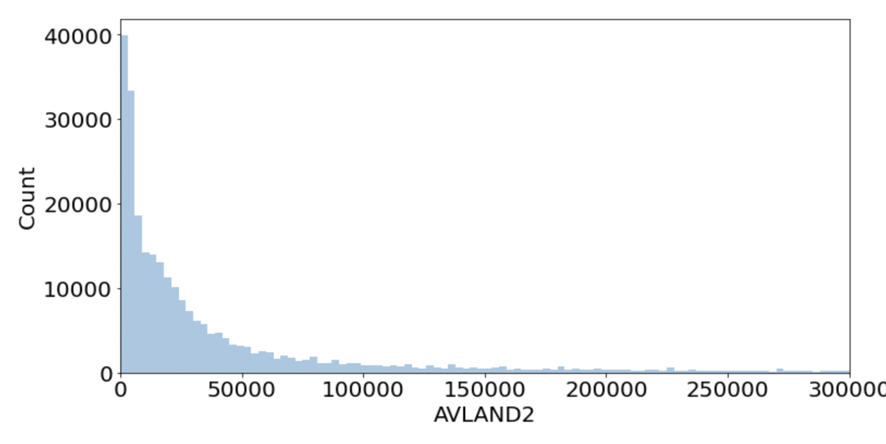

1. **AVTOT2:** Numerical value, containing only 26% populated values, containing 3 as minimum value and value as high as 4.6 million.

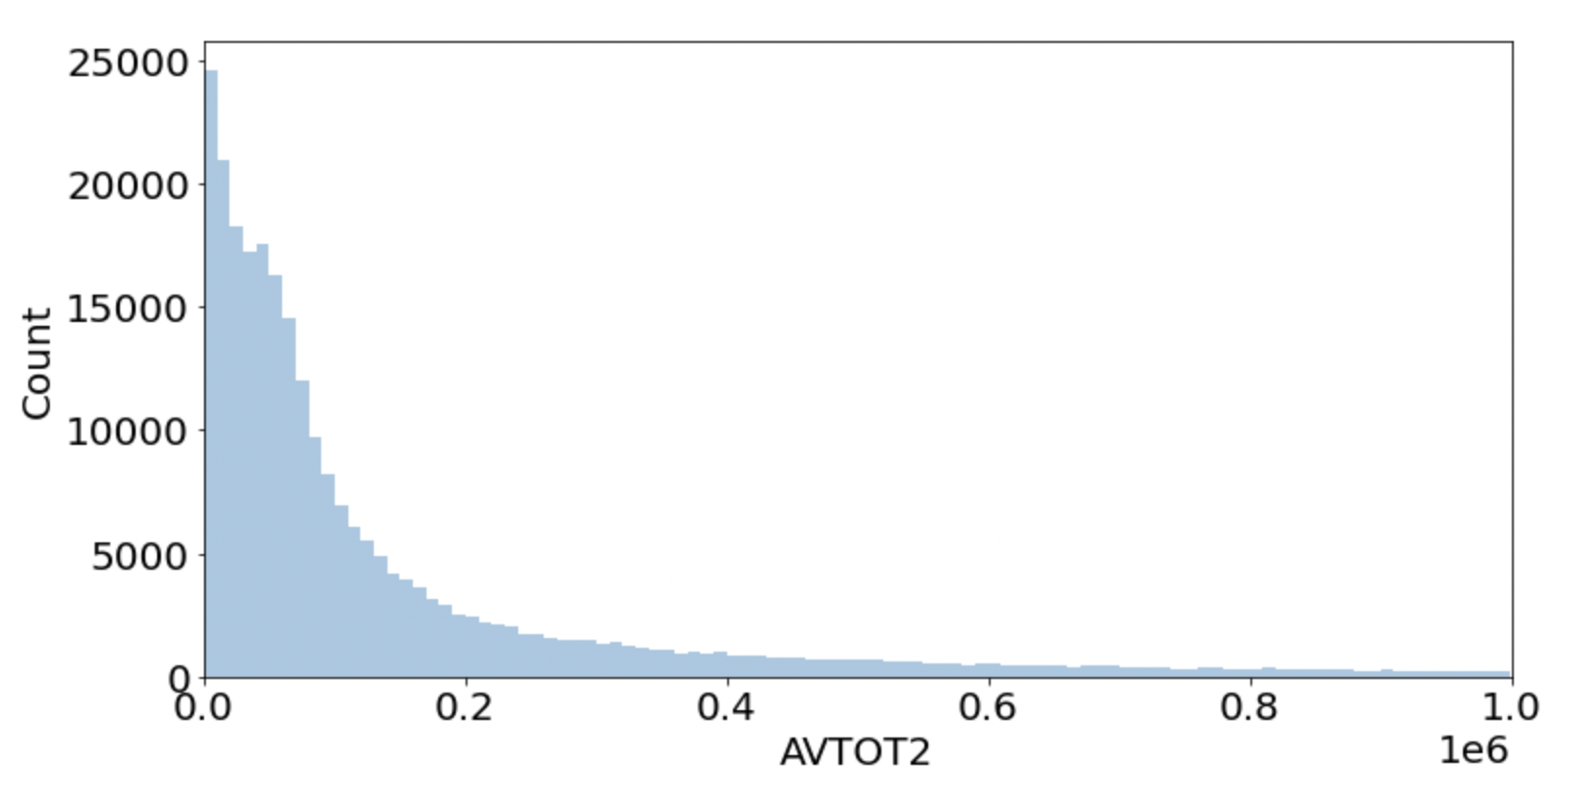

1. **EXLAND2:** Numerical value containing only 8.16% values as populated. Value 2090 has extraordinarily large number of values, 26393.

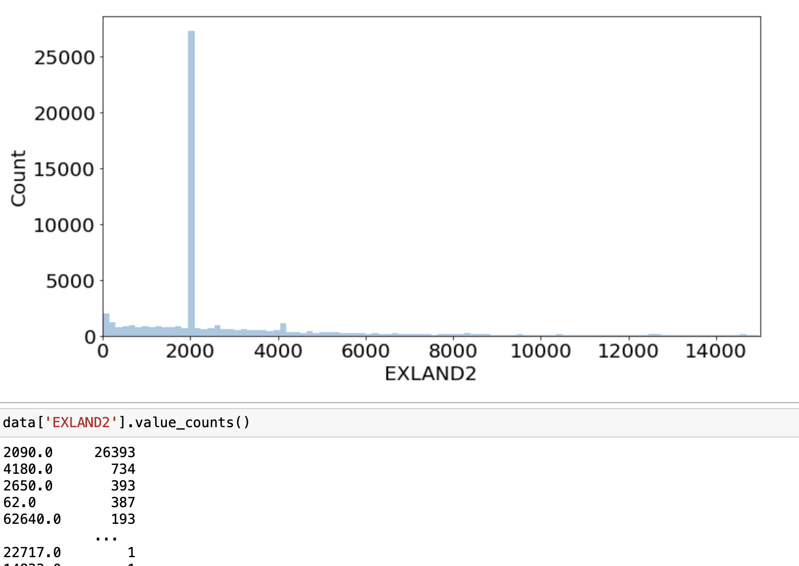

1. **EXTOT2:** Another numerical field which as only 12% values as populated.

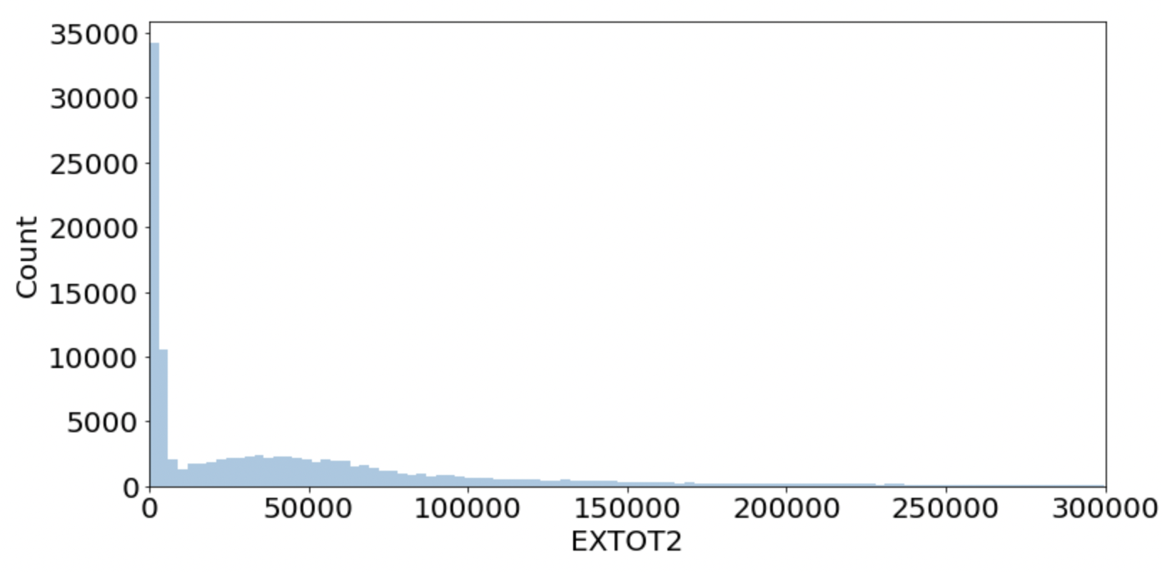

1. **EXCD2:** Categorical field containing 60 unique values. With 1017 having the highest number of values.

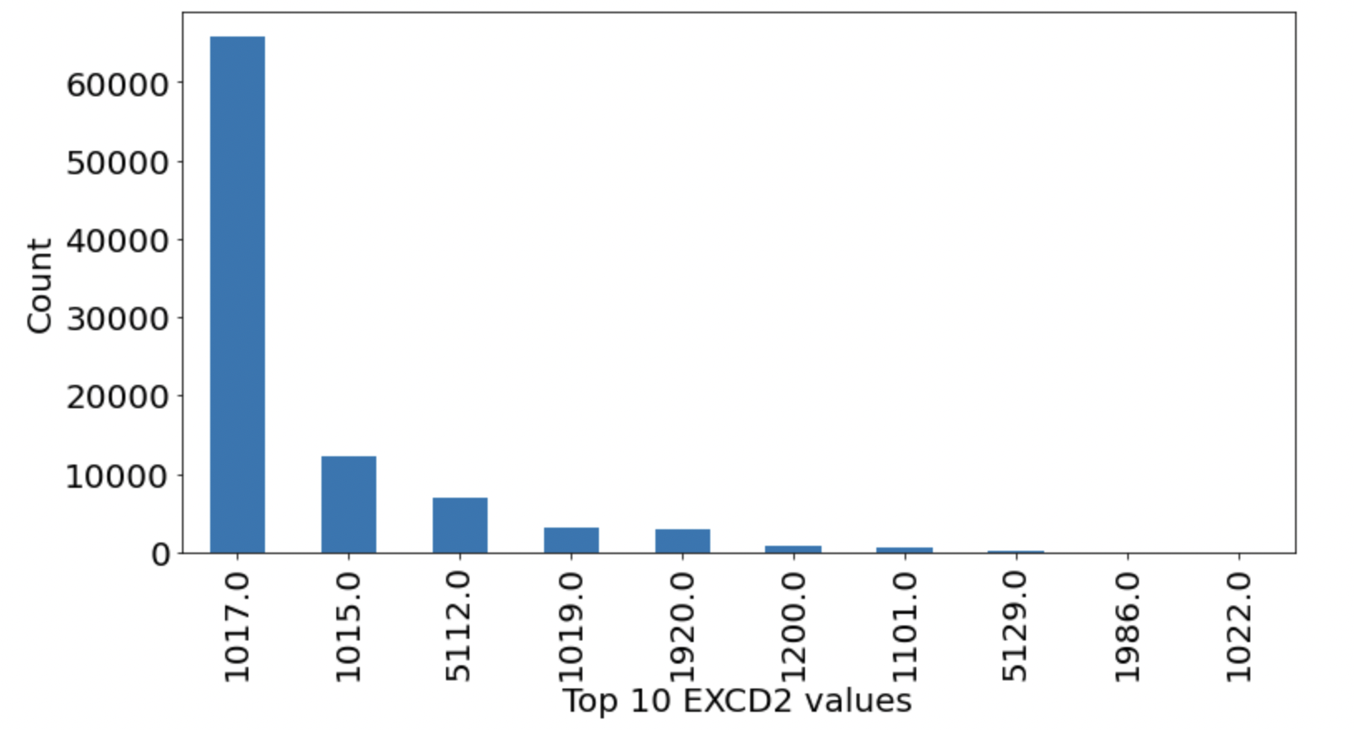

1. **PERIOD:** It contains only one value in the entire dataset with 100% rows populated.
2. **YEAR:** Again, this field also contains one value ‘2010/11’, which is 100% rows populated.
3. **VALTYPE:** Contains only one value ‘AC-TR’ in the entire dataset.